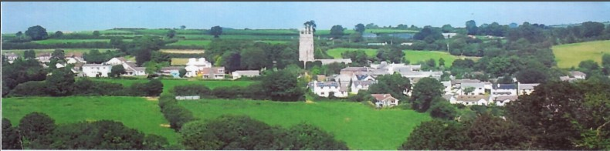

4th August 2025

Dear Councillor,

You are summoned to attend a meeting of North Hill Parish Council on Monday 4th August 2025 at 7.30pm in the Village Hall.

Please find attached the agenda for our meeting. We ask that if any member of the public has issues, they would like to raise that they contact the clerk prior to the meeting so that we can best manage them.

Please remember that the time allotted for Matters of Community Concern is not a forum to discuss what has taken place during this meeting and that any matter raised here would likely be added to the NEXT meeting agenda for discussion.

Yours faithfully,

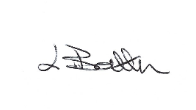

Lena Batten, Clerk to the Council

Members of the public are welcome to attend the meeting. However, we would like those attending to register prior to the meeting by emailing the Parish Clerk. Email: clerk@[northhillparish.org.uk](mailto:northhillparishcouncil@btinternet.com)

**AGENDA**

1. TO RECEIVE APOLOGIES:
2. CODE OF CONDUCT : a) TO RECEIVE DECLARATIONS b) TO GRANT DISPENSATIONS:

3. PUBLIC COMMENTS ON ITEMS ON THE AGENDA ONLY:

4. TO RECEIVE AND APPROVE THE MINUTES OF THE 7th JULY 2025 FULL COUNCIL MEETING:

5. ANY MATTERS ARISING FROM PAST MINUTES NOT ON THE CURRENT AGENDA:

6. TO CONSIDER PLANNING APPLICATIONS RECEIVED FROM CORNWALL COUNCIL BY DATE OF THIS MEETING:

6.1 To note for information - PA25/04632 - Land North East Of West Tremollett, West Tremollett Road, Coads Green, PL15 7NA - Prior notification of agricultural or forestry development for dry storage building – prior approval not required.

6.2 To note for information - PA25/03222 - Penhole Farm, Penhole Road, Coads Green, PL15 7LZ - Proposal Prior Approval for the proposed change of use of four existing agricultural barns to form five dwellinghouses and operational development. New external doors and windows are proposed as part for the development – prior approval not required.

7. ANY APPLICATIONS RECEIVED BEFORE THE DATE OF THIS MEETING: None.

8. TO REVIEW CORRESPONDENCE AND TO AGREED RESPONSES REQUIRED:

8.1 To note for information the clerk has been notified it is a criminal offence for Councillors not to register

Declaration of interests forms within 28 days of election.

8.2 To consider / resolve any donation to the collection fund for Sarah Mason leaving CALC.

8.3 To receive an update in relation to the draft Community Emergency Plan.

8.4 To resolve next steps in relation to painting the barrier yellow in the car park to accompany the signage.

8.5 To accept the quotes for a fire safety box and consider potential purchase of the item.

8.6 To confirm Parnalls Solicitors have stated once they have received the signed ST3 they will submit the

application to Land Registry with a request for the reasons for urgency as there is currently a delay.

9. TO REVIEW DETAILS FOR NORTH HILL PARISH COUNCIL CEMETERY:

9.1 To consider / accept the quotes received for the laying of the path to the cemetery.

9.2 To consider / accept the quotes received for the two requested granite posts.

10. APPROVAL OF THE LIST OF PAYMENTS / RECEIPTS FOR JULY 2025 & TO RECEIVE 31st JULY 2025 BANK STATEMENT:

10.1 AUTHORISATION OF EXPENSES INCLUDING SALARY:

i) £18.00 (PAYE G. Pollard payroll July, dd)

ii) £673.60 (Lena Batten, July net Salary)

iii) £136.93 (Lena Batten, July Tax and NI)

iv) £51.33 (HMRC National Insurance July)

v) £43.64 (room rent)

vi) £30.00 (Code of Conduct training, CALC)

vii) £725.90 (C.C. emptying of dog poo bins for 2025/26)

viii) £66.00 (Code of Conduct training, CALC)

10.2 RECEIPTS:

i) £354.56 (VAT reimbursement).

10..3 To receive bank statement:

Bank Statement as of 31st July 2025 £14806.59.

10.4 To note for information a payment of £47.82 made on the 21st July 2025 deposit for car park signage and payment of £47.83 made on the 24th July 2025 for full payment as previously minuted in July 2025.

11. TO REVIEW MONTHLY BUDGET RECONCILIATIONS:

11.1 Budget Sheet Attached.

12. TO REVIEW MONTHLY RAG: (Red, Amber, Green)

12.1 RAG Sheet attached.

13. REPORT FROM CORNWALL COUNCIL WARD MEMBER COUNCILLOR PARSONS:

14. ITEMS FOR INCLUSION AT THE NEXT MEETING:

15. DATE & TIME OF NEXT MEETING:

16. CLOSE OF BUSINESS: